**OCEAN LAYERS**

[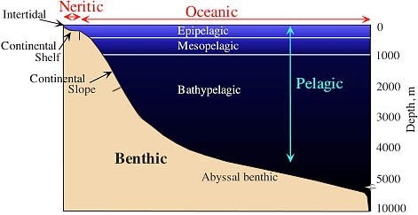](javascript:%20w%20=%20window.open('/onlinecontributors/app?service=external/ViewImageData&sp=1902',%20'1902',%20'resizable,height=500,width=571,scrollbars=yes');%20w.focus();)